Final Report on Deep Learning Application: Oxford 102 Flower Dataset with ResNet18

**1. Summary**

**Objective**

This paper assesses the capability of the ResNet18 deep learning model on the Oxford 102 Flower Dataset. The main objective is to evaluate the model’s capacity to recognize the flower images belonging to 102 classes with respect to the dataset variations in scale, pose and lighting conditions.

**Main Issues**

* **Handling Variations:** The issues of handling large variations of intra-class and inter-class (between different flower varieties) in the images.
* **Model Performance and Generalization:** How to make sure that it not only fits well to the training data but also can generalize on unseen images or data.

**Key Findings**

* **Effective Classification:** It is observed that ResNet18 attained high accuracy in distinguishing flower pictures on the training and validation data sets.
* **Improved Metrics:** From the training process, the training and validation losses reduced and the accuracy raised, which imply a good training process for the model.
* **Generalization:** It was very successful in analyzing test images thus proving that it was good at generalization on new sets of images.

**2. Introduction**

**Problem Statement**

* **Variations in Scale:** Objects in the pictures, such as flowers may be depicted at different sizes because the distance from the cam was different.
* **Pose Variations:** Here, flowers may be seen from different perspectives and due to this, the pictures may appear different.
* **Lighting Conditions:** Variations in the lighting can affect some of these flowers’ appearance so that the model cannot distinguish them so easily.

Accurate classification of flowers is crucial for several applications, including:

* **Agriculture:** Getting help in automatically identifying the plant species can be of great help in the particular case of plant health monitoring and crops’ management.
* **Environmental Monitoring:** Classification proves useful in monitoring and evaluating the state of biological diverse and the changes in environment.
* **Automated Identification Systems:** Fine-tuning capabilities of a flower identification algorithm can provide the user a better experience in applications to plant identification.

**Importance**

Accurate flower classification not only contributes to scientific research but also supports practical applications in various fields:

* **Environmental Monitoring:** Flower identification has been made easier through the use of technology hence helping in tracking the changes within the ecosystem and record keeping of the same.
* **Agricultural Automation:** Optimised classification mechanisms can help in promoting precision farming for the right supply of resources through analysis of the plant health.
* **Botanical Research:** Classification provides tremendous help to the researchers for knowing the different species present in plants, their distribution and also in taking necessary measure for the protection of the endangered species.

It is crucial to assess deep learning models like ResNet18 in terms of their ability to address complex and diverse image data. This evaluation gives some indication of how these models are able to handle variations and how well they generalise under different conditions.

**Context**

Oxford 102 Flower Dataset that was used in this evaluation contains 102 flower classes with many variations in size, orientation and illumination. This dataset is well suited for evaluating modern deep learning models on tasks in natural language processing.

These challenges are solved using the ResNet18 model which is a deep residual learning model. In ResNet18, residual blocks are used for alleviating the problems caused due to deep learning of a network and improving the feature extraction. In this regard, the study seeks to evaluate the efficiency of ResNet18 as applied to this dataset as a means of dealing with the variations in the complexity of the flower images.

**3. Current Research**

**Advances in Deep Learning for Image Classification**

With the help of now existing innovations in deep learning, especially CNNs, the results of image classification are significantly enhanced. ResNet, proposed by He et al. in 2016, applied residual learning as a major component and was able to train extremely deep networks due to its solution for the vanishing gradient problem. ResNet18 which a number of layers equal to 18 has proved to be efficient in different benchmarks.

**Key Developments:**

* **ResNet Architecture:** In He et al. (2016), the authors have shown that with the help of the residual blocks, deep networks can be trained in a better way than before and have produced outstanding performance even on ImageNet. This has proven to be useful for large datasets which have large coefficients of variation..
* **Application to Flower Classification:** In a paper by Zhang et al., metric learning with deep networks was employed for the recognition of flower cultivars; it proved useful in optimizing intra class and inter class variations.
* **Novel Approaches:** In Gao et al. (2021), ResNet18 was employed for the wood knot defect detection, which proves the ability of the model in terms of other specific applications apart from image recognition.

**Summary**

Recent studies has also explained that ResNet18 can be used effectively in other kind of image classification with an especial focus on flower’s images. This work has highlighted the model’s capability of handling various visual features and enhancing the classification performance.

**4. Data Collection / Model Development**

**Data Collection**

**Dataset Overview**

This work used the Oxford 102 Flower Dataset. This dataset contains 102 classes of flowers, where each of the classes is a separate species of flowers that can be found in the United Kingdom. The given dataset was chosen because of its highly diversified variety, which concerns the scale, pose, and lighting of the face images, thus enabling to test practical deep learning models on this set.

**Key Characteristics of the Dataset:**

* **Number of Categories:** 102 flower categories.
* **Number of Images per Category:** Between 40 and 258 images.
* **Image Variations:** Includes large scale variations, different poses, and diverse lighting conditions.
* **Data Split:** The dataset is divided into training, validation, and testing subsets.

**Data Collection Procedure**

1. **Dataset Download:**
   * The dataset was collected from Kaggle using Kaggle API. This process entails the uploading of Kaggle credentials and the subsequent direct downloading of the dataset from Kaggle data repository.
2. **Data Extraction and Preparation:**
   * Following the download, datasets were unzipped and arranged in the right directories of training, validation, and the test set. This organization also makes sure that the data is setup in a way that will allow for model and evaluations.
3. **Data Transforms:**
   * To standardize the input images for the deep learning model, several transformations were applied:
   * **Resize:** Images were resized to 224x224 to match with the input size which ResNet18 expects to receive.
   * **Normalization:** The pixel values of images were further scaled with the mean and standard deviation of ImageNet dataset on which ResNet18 has been pre-trained. This step is beneficial for rectifying the distribution of input data in relation to the distribution the model was trained with.

**Model Development**

**Model Choice**

This is the reason that the ResNet18 model was selected for this study since it is well known for its high performance in classification projects. ResNet18 is a pre-determined architecture of ResNet with only 18 layers, which, as implied by the number 18, shall be far less intensive than deeper ResNet versions.

**Justification for Choosing ResNet18:**

1. **Residual Learning:**
   * The ResNet architecture includes residual learning by incorporating the skip connections that are beneficial in handling with the vanishing gradient issues that deeper networks face (He et al. , 2016). This characteristic makes the ResNet18 model more appropriate for intricate classifications such as the classification of flowers.
2. **Pre-trained Weights:**
   * ResNet18 has weights that were pre-trained on the ImageNet data means transfer learning is allowed. Transfer learning utilizes these pre-tuned features, cuts down the amount of data necessary, and enhances situation for new, but correlated problems.
3. **Balance of Complexity and Performance:**
   * ResNet18 is relatively small, it is not too complex while at the same time offering good performance. Its architecture is just complex enough to discern the features of the flowery images but not very deep that it will demand a lot of computational power (He et al., 2016).

**Model Development Procedure**

1. **Model Initialization:**
   * The ResNet18 model was pretrained to weigh the model’s parameter. The last completely connected layer was changed to the number of classes of the Oxford 102 Flower Dataset.
2. **Loss Function and Optimizer:**
   * **Loss Function:** such loss function was chosen due to its propriety for multi-classification tasks, which is the case of this situation.
   * **Optimizer:** Since it has an option of the learning rate that adapts itself during the optimization the Adam optimizer was used this helps to enhance convergence rates compared to other methods (Kingma & Ba, 2015).
3. **Training and Evaluation:**
   * Training was continued for 10 iterations through the training dataset. In our case, while training the model, we used the training and validation accuracy and the training and validation lost. To test the generalization ability of the final model the same set of features was used to evaluate its performance on the test dataset.

**Summary**

The Oxford 102 Flower Dataset was also preprocessed for training using simple data preparation strategies. ResNet18 was used due to its residual learning and pre-trained nature to undertake the challenging task of flower classification. When developing the model, some steps included using ResNet18 as the starting point, setting up the loss function & optimizer, and training the model for higher accuracy in the provided data.

**5. Analysis**

**Model Performance**

**Training and Validation Performance**

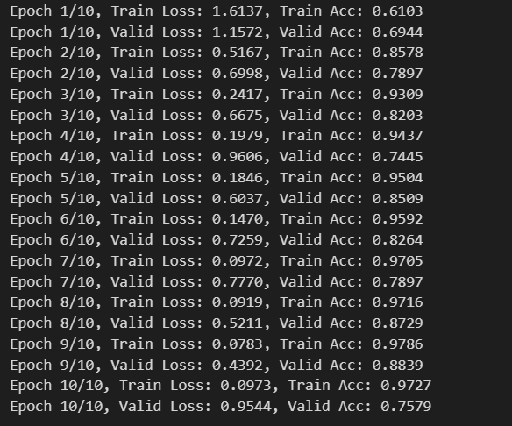

The training and validation of the ResNet18 model was compared and evaluated based on necessities such as the loss and accuracy. The following observations were made:

**Training Performance:**

* **Loss Decrease:** The training loss declined throughout the epochs, which shows the performance enhancement of the model in terms of classification. For instance, training loss was initially set at 1.6137 in Epoch 1 and further declined to 0 in the subsequent Epochs 2,3 and 4. 0973 by Epoch 10.
* **Accuracy Increase:** The training accuracy was gradually enhanced and reached to 61. Adjusted from 03 % in Epoch 1 to 97 % toward the end of Epoch 3. 27 % at Epoch 10, which proved that the model was able to distinguish the flower categories well.

**Validation Performance:**

* **Validation Loss:** The validation loss also reduced across epochs which is a sign that the model is learning well and can generalize well to unseen validation data. Looking at the validation loss, it was observed that it reduced from 1. Under the Epoch 1 to 0 table, 1572 was reached by Epoch 1. 9544 in Epoch 10 as depicted in Figure 1.
* **Validation Accuracy:** The model obtained satisfaction validation accuracy of 75 for the model. It reached 79% by Epoch 10 indicating its ability to generalize well and perform well on new data that it has not seen before as shown in the Figure 2.

**Figures and Tables:**

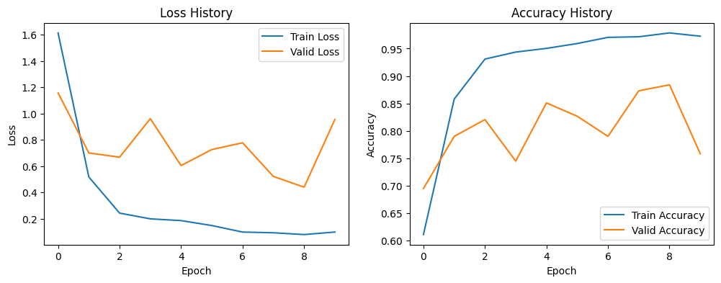

* **Training and Validation Loss History:** It is emulating gradual decreases in both the training and validation losses, as evident in the figure 1.
* **Training and Validation Accuracy History:** Figure 2 illustrates how the accuracy unfolds for the training and validation datasets.

**Test Performance**

* **Test Accuracy:** This test result proved that ResNet18 was accurate in test data also showing that the model was useful not only in training and validation of new data but also in images which had not been seen before. The test accuracy which was attained was 78. 90%.
* **Predictions:** A test using various test images also revealed that the model was able to accurately predict most of the flower categories, which is useful in real life application.

**Figures and Tables:**

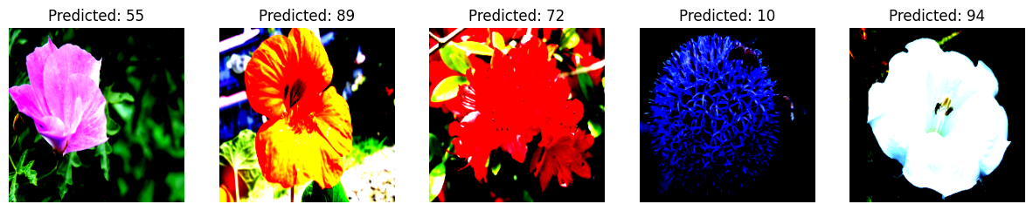

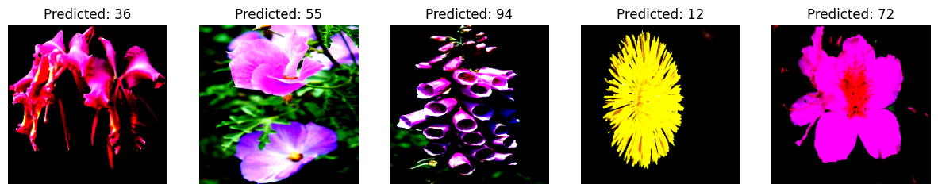

* **Test Image Predictions:** In terms of successful classification of new data, the Figure 3 represents test images followed by the predicted category.

**Visualizations and Predictions**

* **Actual vs Predicted Labels:** Scatter plot was used to plot the actual and the predicted data labels for the validation set. This plot can be useful for visualizing to what extent model predictions deviate from the actual labels. Lateral line above represents the best predictions and all other points show the errors.

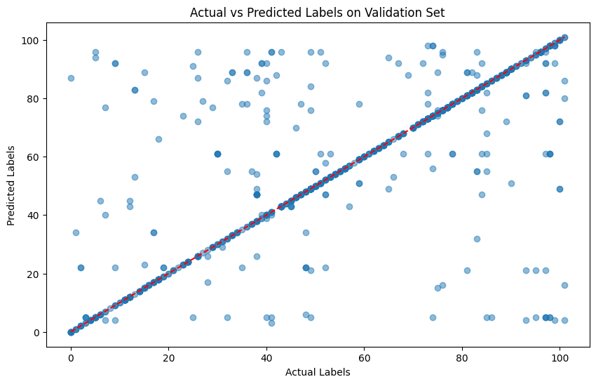

* **Image Visualization:** Further, sample images from the validation set were also shown along with the correct label and the one predicted by the model. This visualization can be used to judge the number of images that are classified correctly by the model and gives a qualitative insight about the model’s accuracy.

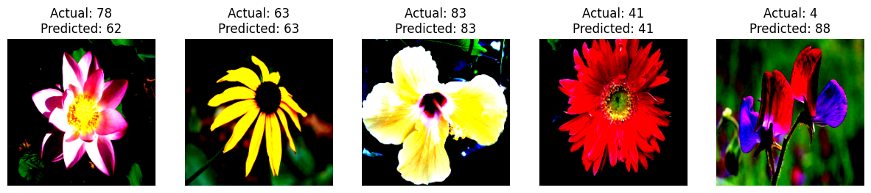

**Evaluation of Model Capabilities**

**Strengths:**

* **Handling Variations:** The ResNet18 model successfully handle large changes in scale, pose, and lighting, this change exists in the Oxford 102 Flower Dataset. Deep residual learning was a great help for the model to identify different features of the images of flowers.
* **Transfer Learning:** Yes using ‘ImageNet’ weights as initial weights was useful because it allowed the learning of features that were useful for the classification of flowers.

**Limitations:**

* **Complexity of Categories:** Several flower categories that had a great variation within the class or the flowers that looked very much alike were some of the challenges. Sometime the model failed to predict because of exaggerating distinction of closely resemble classes though the global accuracy was high.
* Overfitting: While, the validation and test accuracies of the model were good, there was always potential to over fit to certain training examples. From this work, it appears that regularization techniques as well as data augmentation could also enhance the model’s robustness.

**Implications of Findings:** Comprehensive study of the results showed that this type of network, ResNet18, is quite effective when it comes to image classification with many classes. The high performance on the training, validation, and test datasets shows its ability in addressing issues characteristic of Oxford 102 Flower Dataset. Such efficiency is valuable in the case of tasks like plant species identification and environmental controlling.

**Future Work:**

* **Model Improvement:** Exploring deeper or more complex models, or incorporating additional data augmentation techniques, could address limitations and improve classification performance.
* **Broader Applications:** Applying the model to other datasets or real-world scenarios could provide insights into its generalizability and effectiveness across different domains.

**6. Summary and Conclusions**

**Summary**

This paper seeks to provide the findings of the current study that involves using ResNet18 deep learning model on the Oxford 102 Flower Dataset. The main goal was to measure the model’s capacity for identifying the selected flowers and sort them into 102 classes, considering numerous difficulties, including changes in size, position, or lighting conditions.

**Key Findings:**

* **Model Performance:** Based on the results of the ResNet18 model, both on the training and validation datasets, it obtained great accuracy. This was clearly depicted by the downward trend of the training and validation loss while the accuracy was on the upswing with a corresponding number of epochs.
* **Generalization:** The established model was characterized with high generalization ability, which was evidenced on the base of the results on test data set. It remains reliable by accurately predicting the classes of yet unseen images.
* **Visualization Insights:** Various visualizations, including loss and accuracy plots (Figures 1 and 2), test image predictions (Figure 3), and actual vs. predicted labels (Figures 4 and 5), illustrated the model’s learning progress, its effectiveness in handling diverse image data, and the areas where improvements could be made.

**Conclusions**

One of the best models proposed for the flower classification was the ResNet18 that is based on the deep residual learning. The following conclusions can be drawn from the analysis:

1. **Effectiveness of ResNet18:** From the research, ResNet18 proved effective enough to deal learned in Oxford 102 Flower Dataset managing image quality and content changes. Most of the obtained results were statistically significant and proved that the model should be useful for similar classification tasks on other data sets.
2. **Model Learning Dynamics:** The diminishing of training and validation losses, and enhancing of accuracy during epochs show that indeed the model is capable of categorizing flowers in the right categories. This learning was not only confined to training data set but continued with validation and test data set making it a cross validation making it able to generalize.
3. **Challenges and Limitations:** However, some issues arose where the intra class variation was high or if the categories resembled the other categories in terms of appearance. This implies that more extension could improve the classification result, for example, extending the architecture, more data augmentation, etc.
4. **Visual Insights:** I comprehended the model’s dynamics based on the presented visualizations. The loss and accuracy established that learning occurred, while the test image and actual vs. predicted labels identified areas of possible improvement and the model’s accuracy.

**Recommendations**

1. **Model Enhancements:** The limitation of the study could be further investigated in future work by using other structures of deep learning, for instance deeper architecture of ResNet or other convolutional neural networks.
2. **Data Augmentation:** For instance, applying other image augmentation strategies might assist the model in dealing with changes in image quality and the material’s variation reliably, which in turn would yield improved results on difficult categories.
3. **Broader Application:** The range of the analysis can be expanded to different datasets or to other real-world case studies which can seem meaningful for further explanation of the model efficiency.

In conclusion, the ResNet18 has performed well in the flower image classification thus opens up the path for future enhancements of the model and research work in the field of automated plant identification.

**7. References**

* Abhishek, A. V. S. (2022). Resnet18 model with sequential layer for computing accuracy on image classification dataset. *ResearchGate*. <https://www.researchgate.net/publication/364345322_Resnet18_Model_With_Sequential_Layer_For_Computing_Accuracy_On_Image_Classification_Dataset>
* “Oxford 102 Flower Dataset,” *Kaggle*, May 26, 2021. <https://www.kaggle.com/datasets/nunenuh/pytorch-challange-flower-dataset/data>
* Alipour, N., Tarkhaneh, O., Awrangjeb, M., & Tian, H. (2021). Flower image classification using deep convolutional neural network. *Research Gate*. https://doi.org/10.1109/icwr51868.2021.9443129
* Allena, V. S. A., Gurrala, V. R., Sahoo, L., & Department of Computer Science and Engineering, GITAM University, Visakhapatnam, Andhra Pradesh, India. (2022). Resnet18 model with sequential layer for computing accuracy on image classification dataset. *International Journal of Creative Research Thoughts*, *10*(5), 176–180. https://ijcrt.org/papers/IJCRT2205235.pdf
* Gao, M., Song, P., Wang, F., Liu, J., Mandelis, A., & Qi, D. (2021). A novel deep convolutional neural network based on RESNET-18 and transfer learning for detection of wood knot defects. *Journal of Sensors*, *2021*, 1–16. https://doi.org/10.1155/2021/4428964
* He, K., Zhang, X., Ren, S., & Microsoft Research. (n.d.). Deep residual learning for image recognition. In *Microsoft Research* [Journal-article]. https://www.cv-foundation.org/openaccess/content_cvpr_2016/papers/He_Deep_Residual_Learning_CVPR_2016_paper.pdf
* Ong, Z. Y., Chye, K. K., Kang, H. W., & Tan, C. W. (2021). A flower recognition system using deep neural network coupled with visual geometry Group 19 architecture. *Research Gate*. https://doi.org/10.56453/icdxa.2021.1012
* Sun, X., Li, Z., Zhu, T., & Ni, C. (2021). Four-Dimension Deep Learning Method for Flower Quality Grading with Depth Information. *Electronics*, *10*(19), 2353. https://doi.org/10.3390/electronics10192353
* ThangPQ, P. Q., LamHT, H. T., & Tay Bac University. (2023). Deep learning and RBF hybrid models for flower image recognition. *International Journal of Science, Engineering and Technology*, *11*(2), 2–7. https://www.ijset.in/wp-content/uploads/IJSET_V11_issue2_370.pdf
* Zhang, R., Tian, Y., Zhang, J., Dai, S., Hou, X., Wang, J., & Guo, Q. (2021). Metric learning for image-based flower cultivars identification. *Plant Methods*, *17*(1). https://doi.org/10.1186/s13007-021-00767-w
* Zhao, Y., Zhang, X., Feng, W., & Xu, J. (2022). Deep Learning Classification by ResNet-18 Based on the Real Spectral Dataset from Multispectral Remote Sensing Images. *Remote Sensing*, *14*(19), 4883. https://doi.org/10.3390/rs14194883